Notes on
Finding Volume of a Prism
Volume is the amount of space that a substance or object occupies, or that is enclosed within a container. The containers we are interested in are prisms.
A prism is a 3-dimensional object that has 2 polygonal bases and the faces are rectangles. The 2 types of prisms we are interested in are TRIANGULAR PRISMS and RECTANGULAR PRISMS.
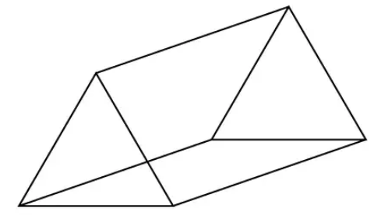This is what a triangular prism looks like.
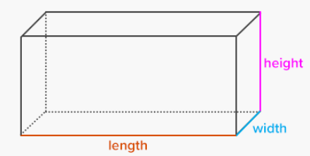This is what a rectangular prism looks like.
To find the area of a prism, the formula you use is V = Bh, where ‘V’ represents volume, ‘B’ represents the AREA of the base of the shape, and ‘h’ represents the height of the shape.
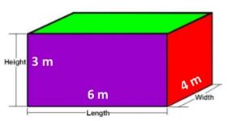To find the volume of this rectangular prism, we first find the area of the base, which is 4 by 6 rectangle. So, to find its area simply multiply 4 and 6 to get 24 square meters. Next, to find the volume, we multiply this area by 3 meters, the height of the prism. So, 24 x 6 = 144, so the volume is 144 meters³.
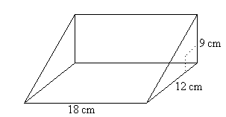To find the volume of this triangular prism, we first find the area of the triangular base, so A = ½ x 12 x 9, or A = 54 square centimeters. Next, we multiply the area of the triangle by the height of the prism, which is 18. So V = 54 x 18 = 972 centimeters³.

